**Computer Organization**

**Lab Work**

**IIIT Sonepat**

**Submitted To: Submitted By:**

**Ms. Sunita Sharma Gaurav Yadav**

**Assistant Professor CSE**

**IIIT Sonepat 11911038**

* **Adding two numbers using assembly language:**
* ***Source Code:***

.model small

.stack 200h

data segment

a db 3

b db 5

data ends

code segment

assume cs:code ds:data

start:

mov ax,data

mov ds,ax

mov bl,a

mov dl,b

add dl,bl

add dl,48

mov ah,2

int 21h

mov ah,4ch

int 21h

code ends

end start

* ***Output:***

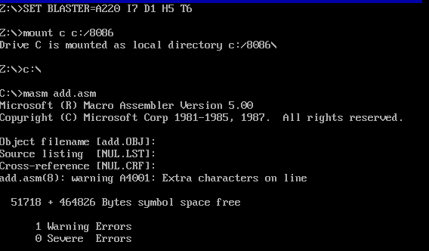

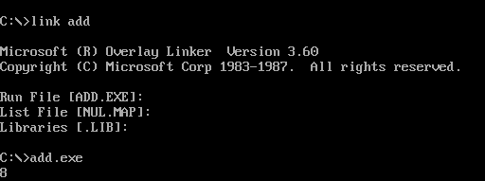

* **Subtracting two numbers using assembly language:**
* ***Source Code:***

.model small

.stack 200h

data segment

a db 1

b db 5

data ends

code segment

assume cs:code ds:data

start:

mov ax,data

mov ds,ax

mov bl,a

mov dl,b

sub dl,bl

add dl,48

mov ah,2

int 21h

mov ah,4ch

int 21h

code ends

end start

* ***Output:***

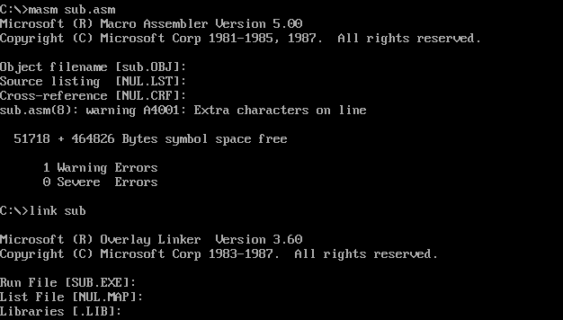



* **Multiplying two numbers using assembly language:**
* ***Source Code:***

;program to multiply two numbers

.model small

.stack 100h

.data

.code

main proc

mov al, 5

mov bl, 4

mul bl

AAM

mov ch, ah

mov cl, al

mov dl, ch

add dl, 48

mov ah, 2

int 21h

mov dl, cl

add dl, 48

mov ah, 2

int 21h

mov ah, 4ch

int 21h

main endp

end main

* ***Output:***



